Welcome to Liss Junior School PTA
The PTA at Liss Junior School is an active one and hosts a number of events and initiatives each year, including our very successful Fireworks Night, Christmas Fair, quiz nights as well as other events and initiatives.
We have been very lucky in our support from parents and the wider community over the past few years and have been able to buy a number of items from the school. We provide many small items, such ice lollies on Sports Day, wet day play toys, and Wii Fit games, to much larger items, such as the fantastic kiln, which has already been well used, and the “Monster” play wall in the playground.
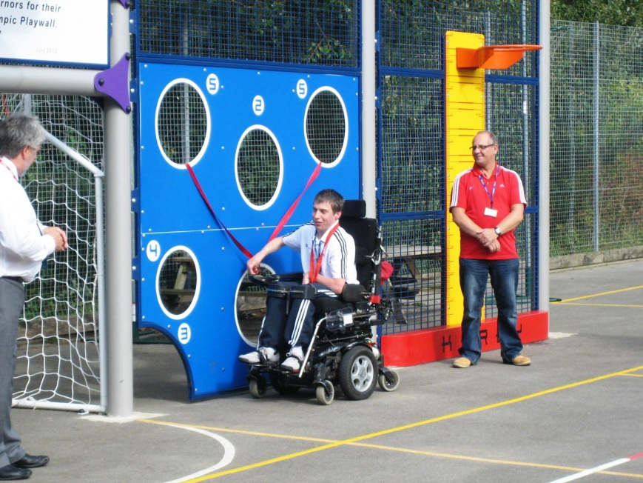
Boccia champion David Smith officially opening our Olympic “Monster Play Wall”
As with all PTAs, we rely on parents support, and always welcome any help any of our parents wish to give. This might be anything from baking a cake, to attending committee meetings and having an elected role on the committee – and everything in between!
If you are interested in helping the PTA in any capacity, please don’t hesitate to contact our Chairperson, Karen Frost (kbf190998@hotmail.com or leave a note with school reception), or feel free to attend any PTA meeting (meeting dates are usually posted on our blog and newsletter). We are also always on the look-out for donations for raffles and silent auctions at the school, so if you are able (perhaps if you have your own business) we would welcome items/services for this purpose too.
Current PTA Committee
Chairperson – Karen Frost
Secretary – Silvia Jauma
Treasurer – Sarah Redfern
Newsletter & Blog – Karen Frost (with Silvia Jauma)
Purchasing – Carmen Alemparte
Publicity – Julie Hodgkinson
Second Hand Uniform – Sam Davy
LiDBA – Sarah Hills

